MEDIA RELEASE
For immediate release 15 October 2018
Kerrie and Spence have a secret weapon on The Block
Kerrie and Spence’s chances of winning The Block may have just increased after their property was shown to hold over $3 million in tax deductions for the future buyer should they decide to rent it out.
This development could increase the price that property investors are willing to pay for the property and give the pair an edge during the final auction.
The Australian Taxation Office allows owners of income producing properties to claim deductions for the wear and tear that occurs as a building gets older and items within it wear out. Each property is unique and holds different depreciation benefits.
BMT Tax Depreciation has worked with more than half a million Australian property investors to help uncover these lucrative tax deductions and recently assessed The Block apartments for their hidden depreciation values.
The CEO of BMT, Bradley Beer said that The Block properties hold millions of dollars in depreciation value with Kerrie and Spence, Courtney and Hans and Hayden and Sara leading the way.
“Savvy investors often assess the depreciation potential of properties before they make an offer,” said Bradley Beer.
“In this case, Kerrie and Spence will have a large competitive advantage come auction day with their property holding $100,000 more deductions than their closest rival.”
From the initial BMT assessment, Kerrie and Spence’s property holds $3,104,786 in total depreciation value over the life of the property. This is followed by Courtney and Hans ($2,977,031), Hayden and Sara ($2,877,638), Bianca and Carla ($2,686,636) and Norm and Jess ($2,650,481). 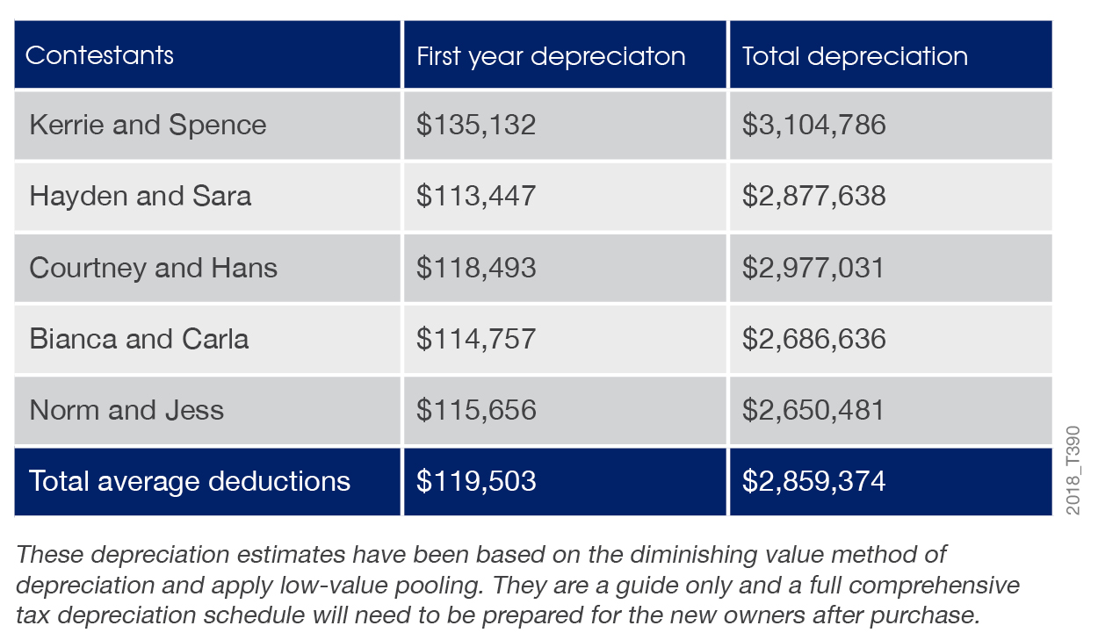

“If an investor buys Kerrie and Spence’s property, they will be able to claim $135,132 in depreciation deductions in the first year alone. This is nearly $17,000 more than the next closest property,” said Bradley Beer.
“While depreciation benefits aren’t the only factor that savvy investors use to assess a property’s worth, they often play a huge part as they can increase the cash flow derived from a property.
“In a softening real estate market, cash flow potential is often front of mind for experienced investors and this scenario may mean that Kerrie and Spence’s property will be keenly watched by investors come auction day,” said Bradley Beer.
Mr Beer will be appearing on The Block on Tuesday the 16th of October to discuss the depreciation findings with the contestants.
Property Investors that are interested in better understanding the tax deductions that could be available to them can utilise BMT’s free online tax depreciation calculator.
- ENDS –
For all media enquires please contact:
Bradley Beer
CEO, BMT Tax Depreciation
Phone: 0413 271 777
Email: media@bmtqs.com.au

About BMT Tax Depreciation
BMT Tax Depreciation (BMT) is a Quantity Surveying company specialising in the provision of tax depreciation schedules for residential and commercial investment properties. Commencing business in 1997, demand from property investors nationally has seen business expand Australia-wide with offices now located in Sydney, Parramatta, Melbourne, Brisbane, Newcastle, Adelaide, Perth, Gold Coast, Cairns, Canberra, Hobart and Darwin.

